**LAB 5**

I have done all the 3 task including the Extra Credit task

Task 1: Simple state functionality, corresponds to program task1.js

Task 2: Persist entries to the flat file system, corresponds to program task2.js

Task 3: EXTRA CREDIT TASK: Persist entries to MongoDB corresponds to program task3.js

**For Task 1: Simple state functionality**

Source Code: task1.js

***1. Create a landing page that remembers who you are***

1. Goto *URL “localhost:8081/”.* If the user has not been to the site then the user is asked for her/his first and last name, and remember it the next time s/he visits the site. Further, the user is prompted to complete the registration.

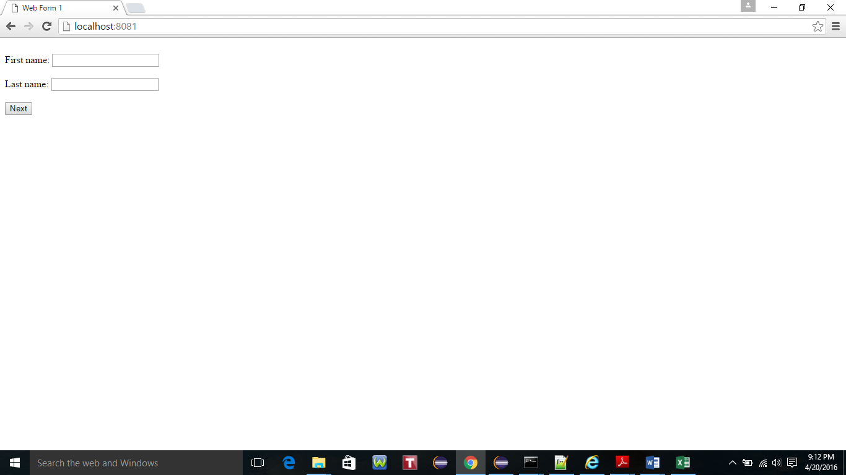

2. Enter the First name and Last name and click button ‘Next’.

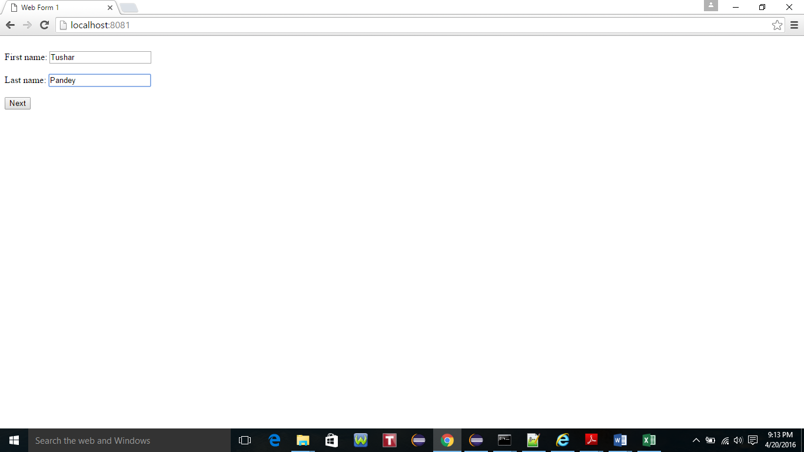

3. Select the programming languages known and click Next button.

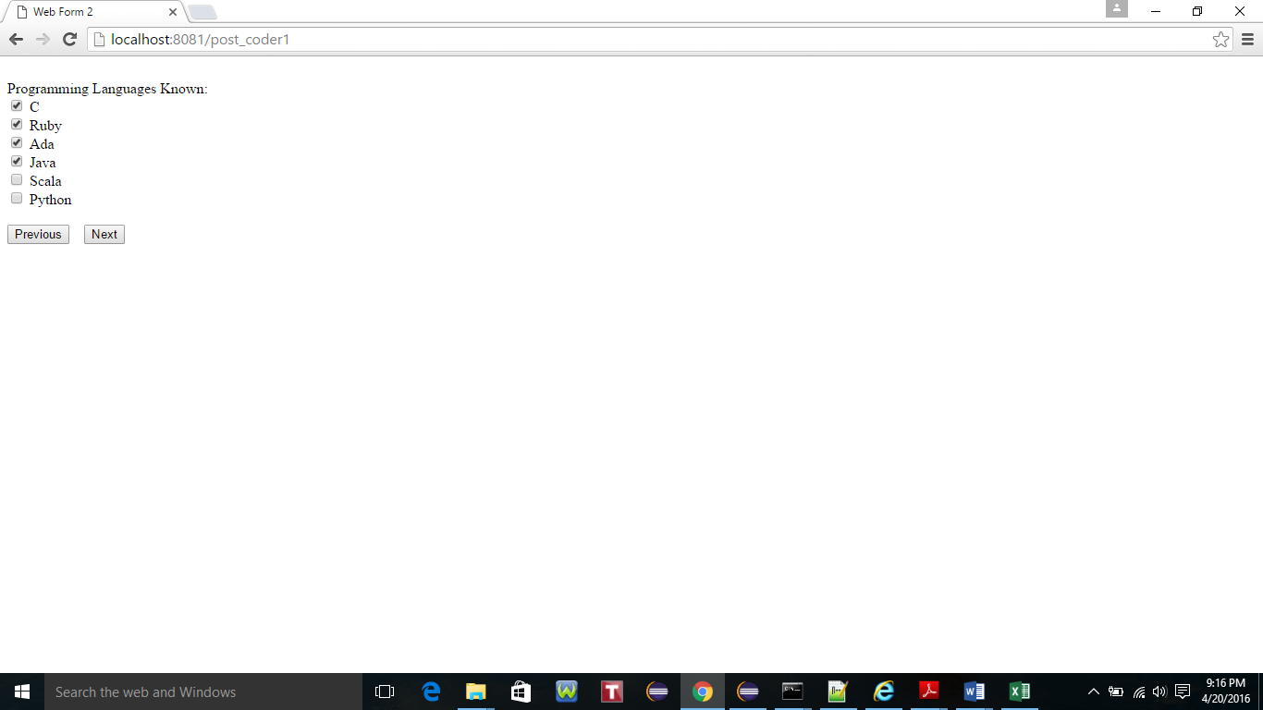

4. Select the Available on Day(s) of the week and click Next button.

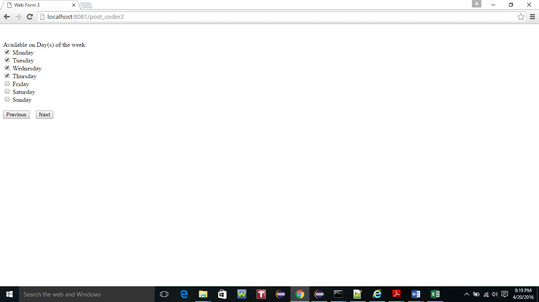

5. Enter the Contact Number and click next to Review all the information entered so far on the Next screen.

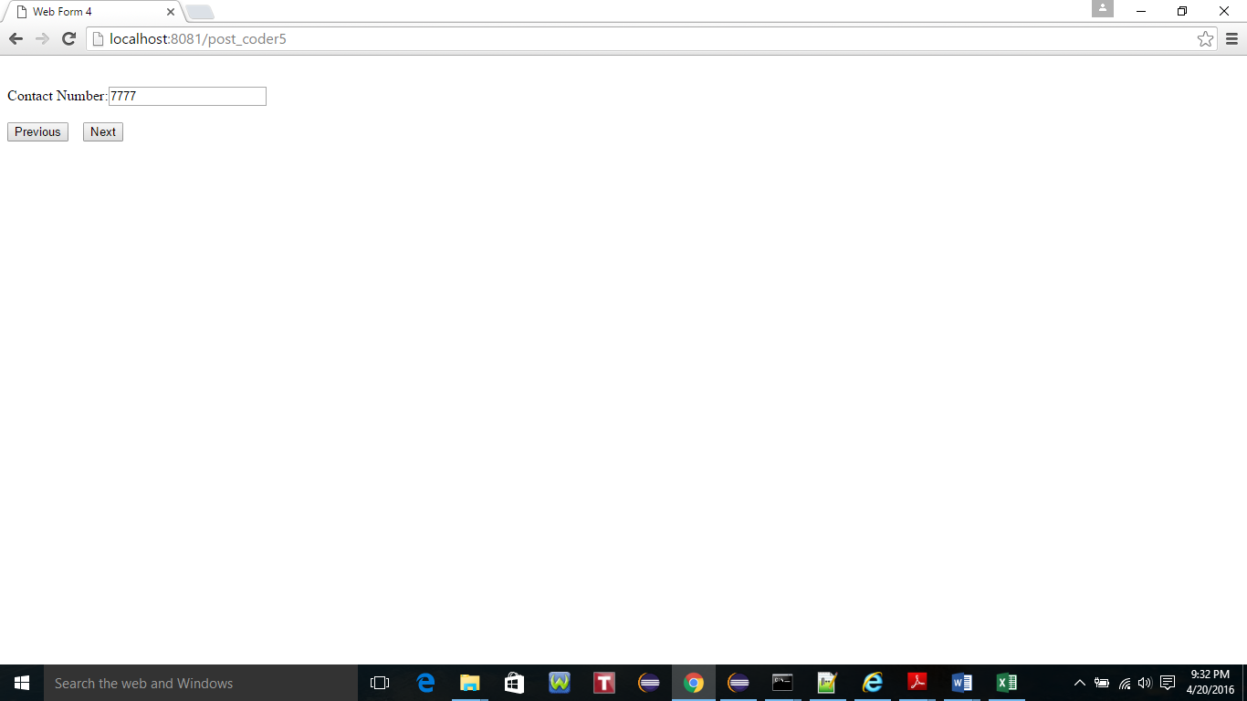

6. Verify the details entered and Click Submit to complete the registration process.

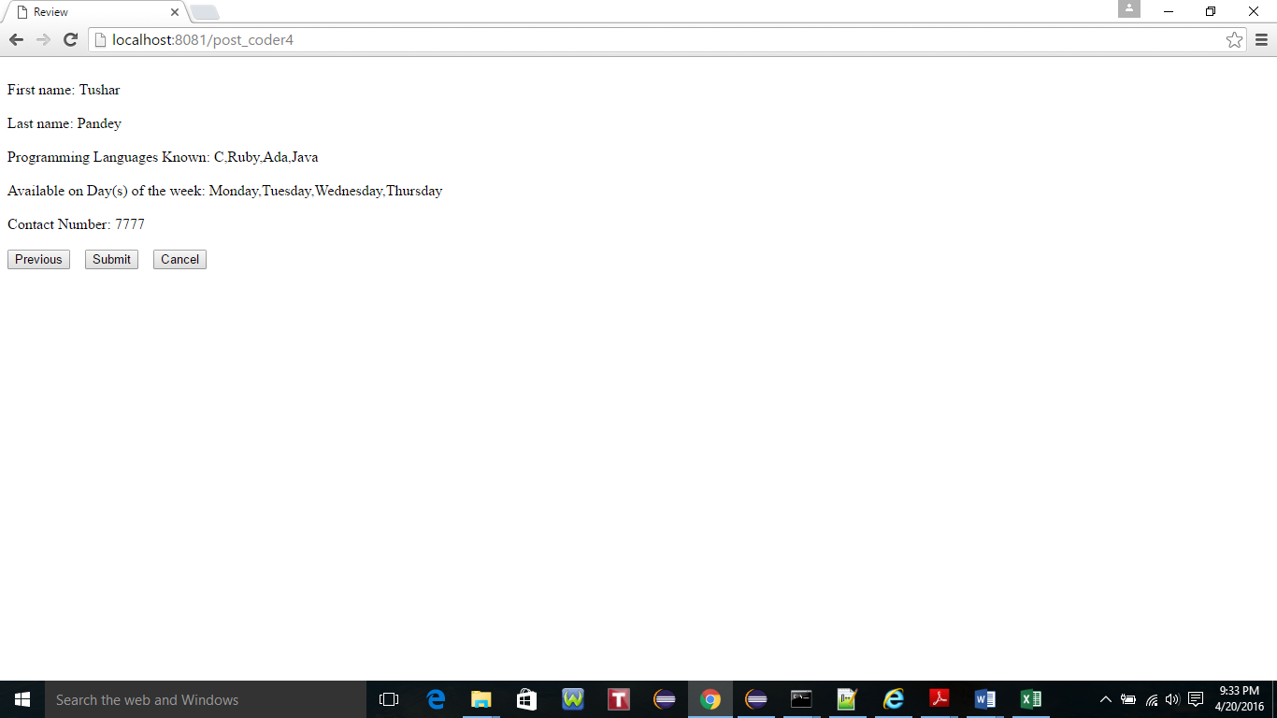

7. Upon submission of the form the control returns to the first form as shown below.

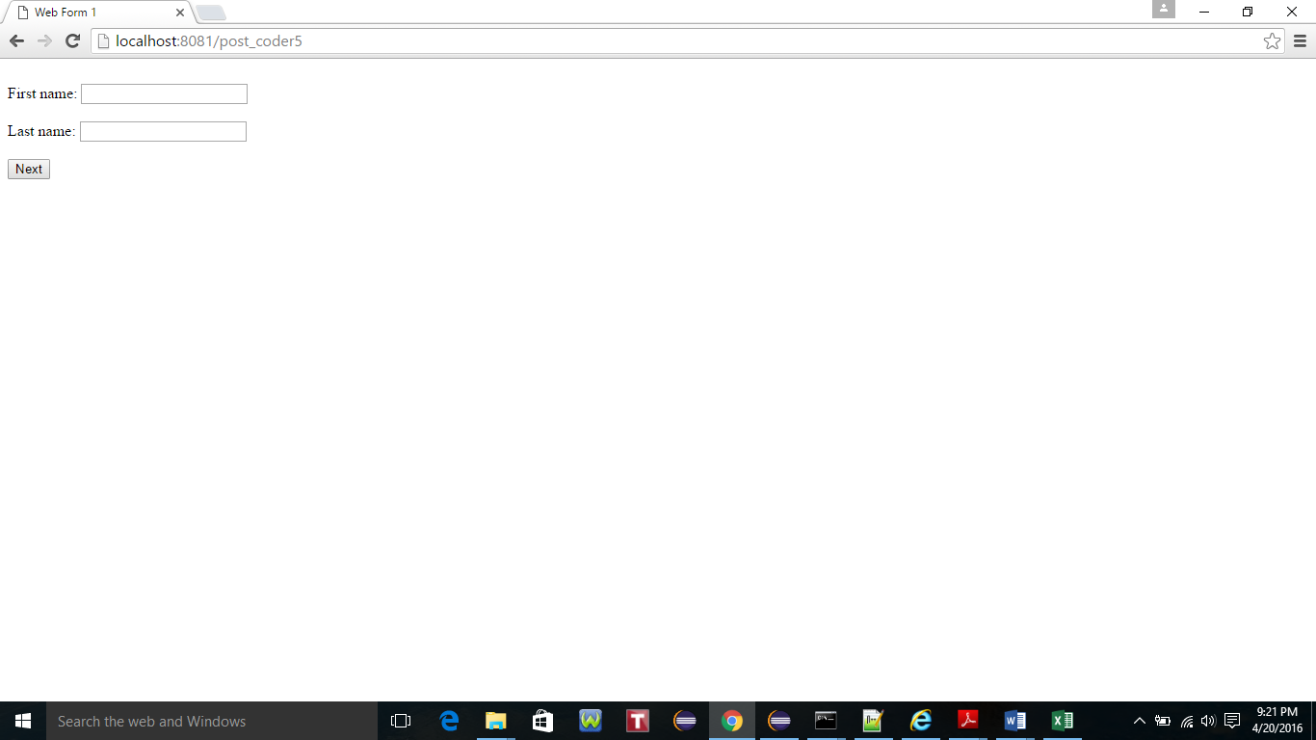

8. Total No. of records including the record submitted by the user ‘Tushar Pandey’ is 8.

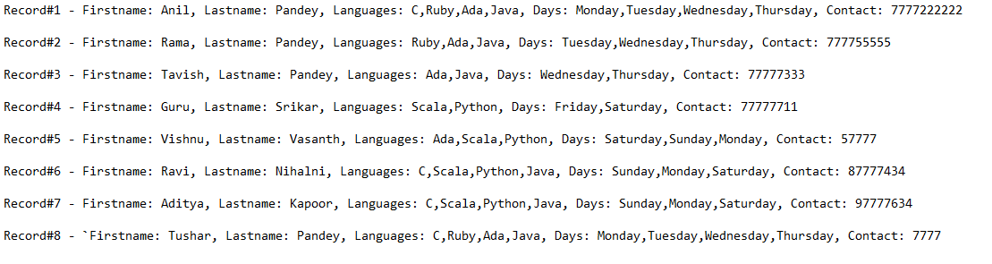

9. Now, Open the *URL “localhost:8081/” in the new browser window as shown below for testing the same functionality for an existing user. The program filters the top 3 results based on the preferences of the attributes of the user.*

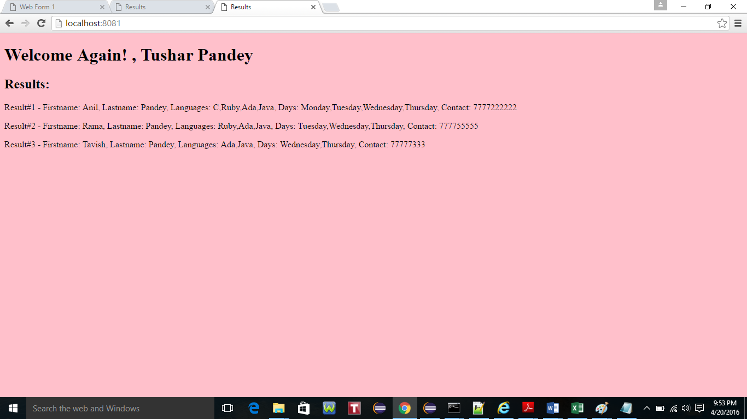

***2. Make a multi-page web form***

1) Go to *URL “localhost:8081/”.* Input First name and last name and click next to proceed,

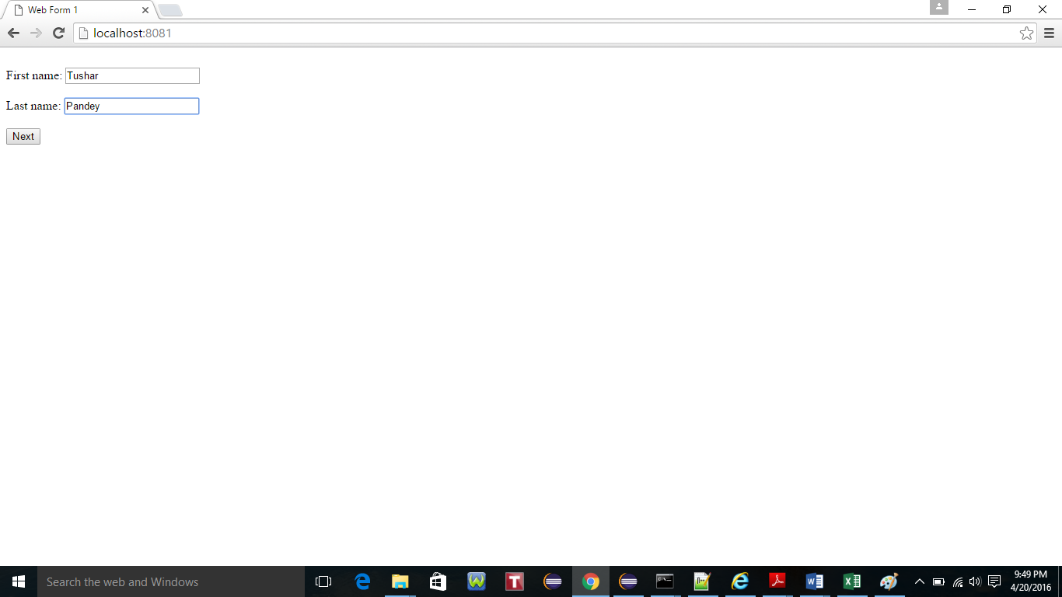

2) Select appropriate Programming languages known and click Next.

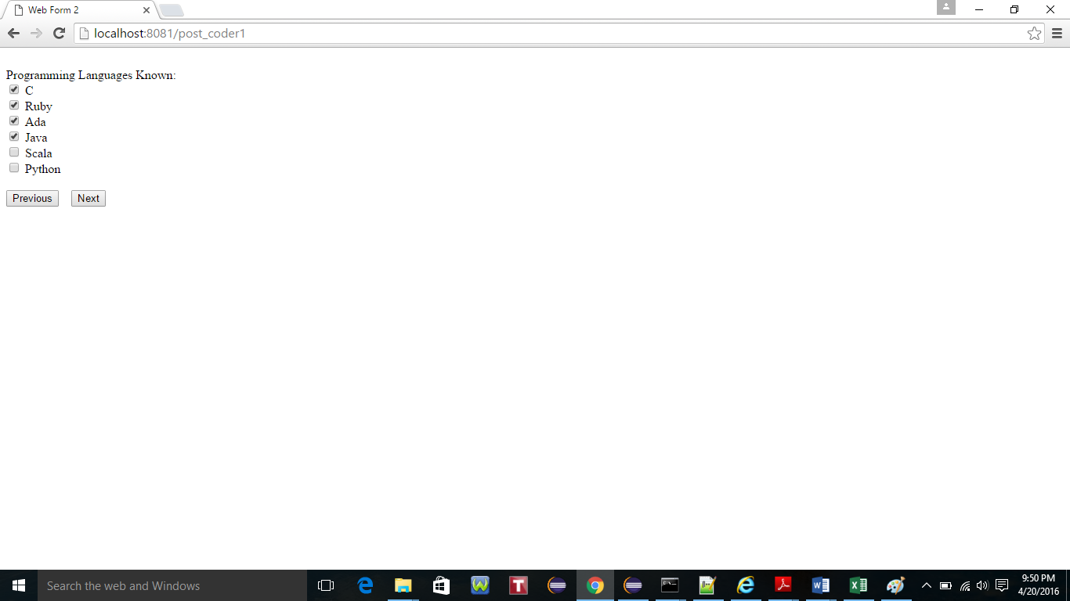

3) Similarly, select the values for Days of the week and click next to proceed.

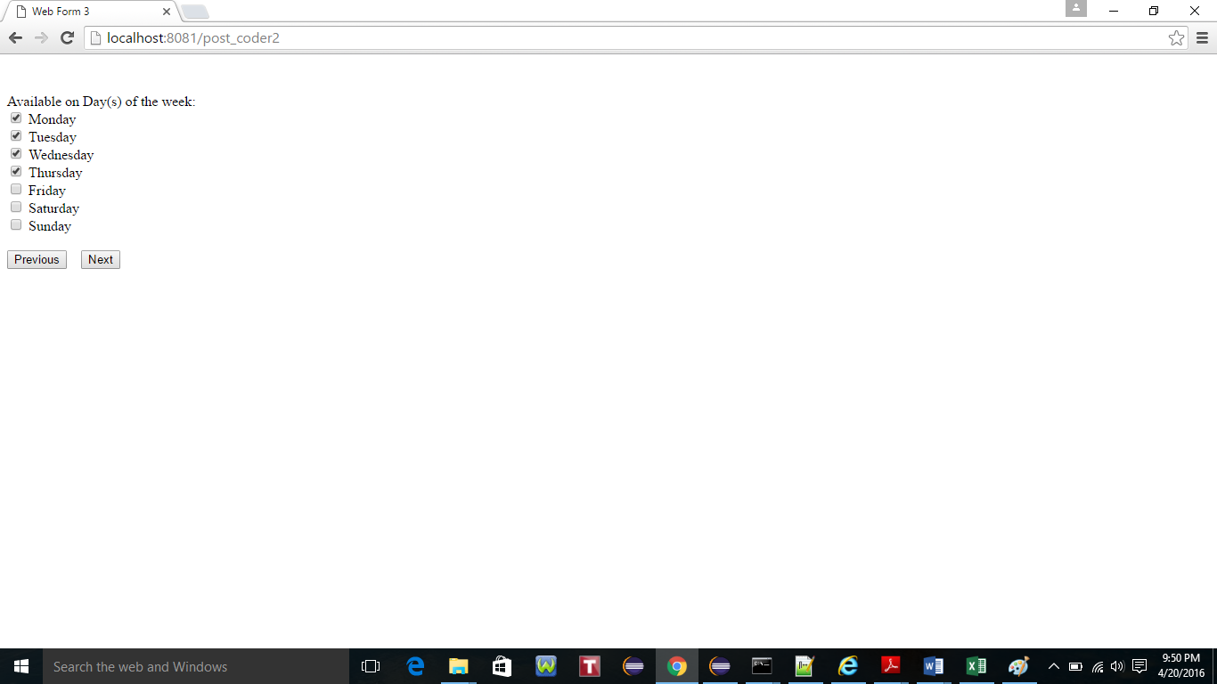

4. Input the value for Contact and click Next to proceed.

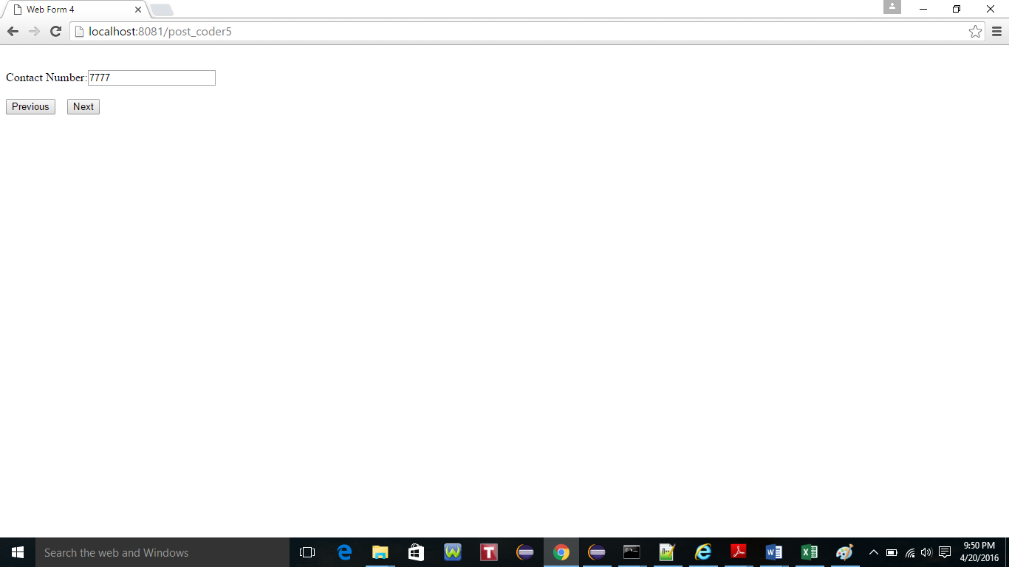

5. Review the information entered in the previous screen and click Submit to record. The user can click Cancel to return back to the First page.

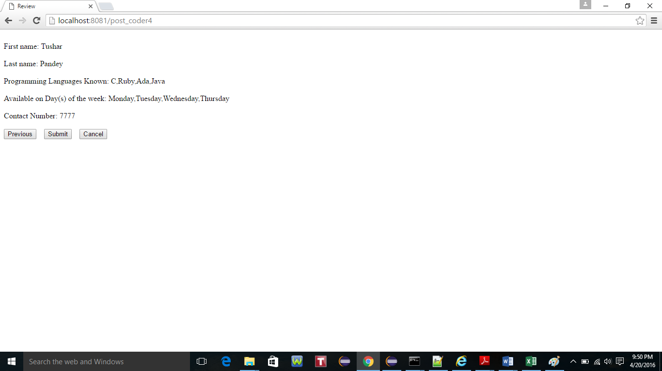

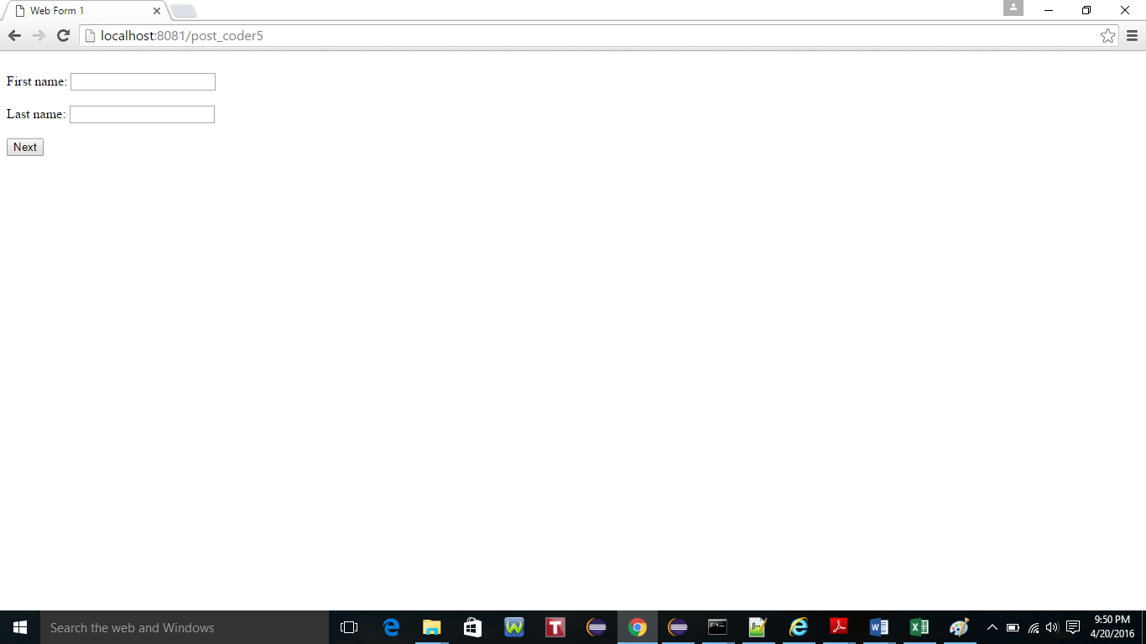

***3. Return the proper response error codes (15)***

1. Proper Http response codes have been handled in the code like HTTP Status code **404:** File Not Found. **500:** Internal Server Error and **405** for Method Not Allowed. Created jade views 404.jade, 500.jade and 405.jade for handling HTTP response error codes. Proper response codes are thrown if a route that has only the GET verb defined receives a POST request.

Similarly, proper response code has been thrown if a route that has only the POST verb defined receives a GET request. Below snapshot displays one of the HTTP response error codes.

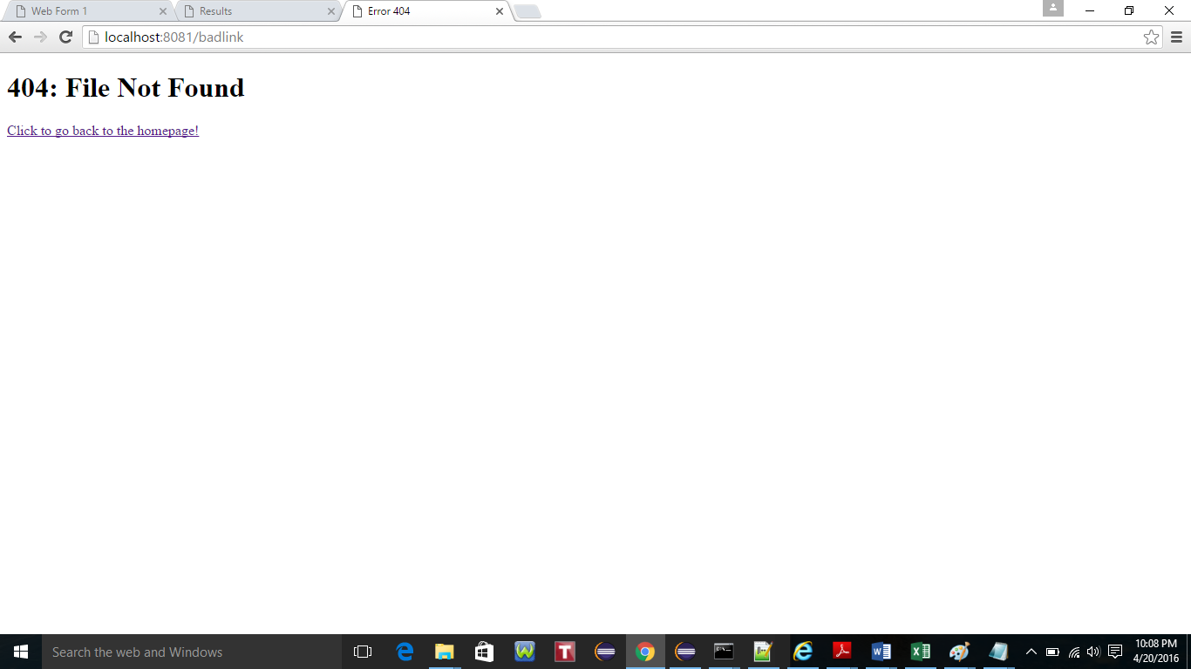

**Task 2: Persist entries to the flat file system**

Source Code: task2.js

1. For this task the in-memory data structure from Task 1 was persisted to a flat filesystem **codersArray.txt**. For this lab JSON was used to achieve it.

The filesystem location for storage is **”./codersArray.txt”**

To change the filesystem location please edit the program task2.js and provide the appropriate location in line no. 478 and 492 where writeFile command is used and path is provided.

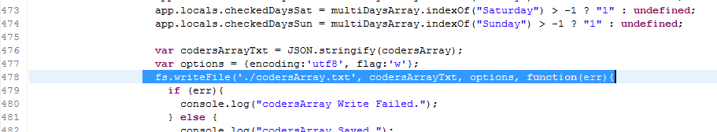

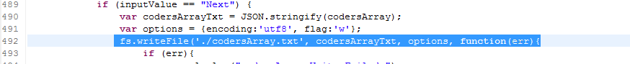

2.Run node task2.js on terminal

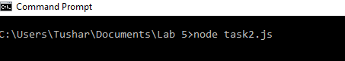

3.Goto url ‘localhost:8081’. Create a user record by providing the details like firstname and last name. Click Next button.

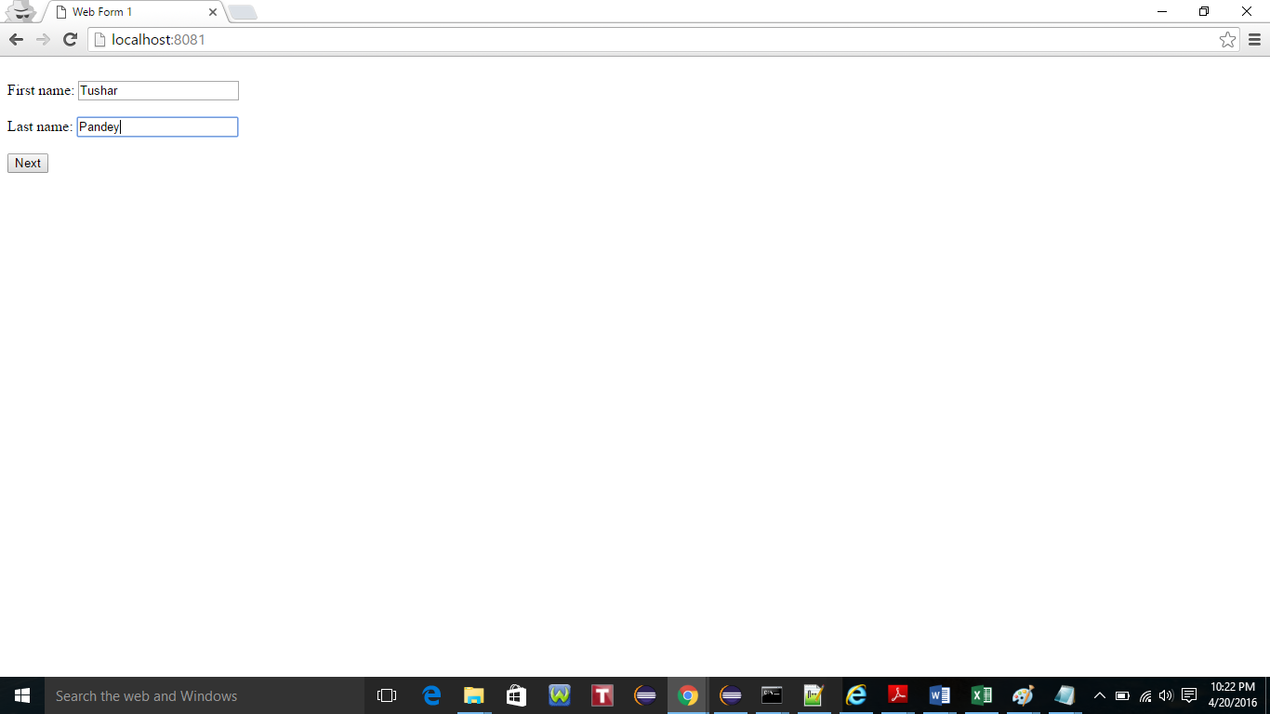

4. Select the programming languages known and click Next button.

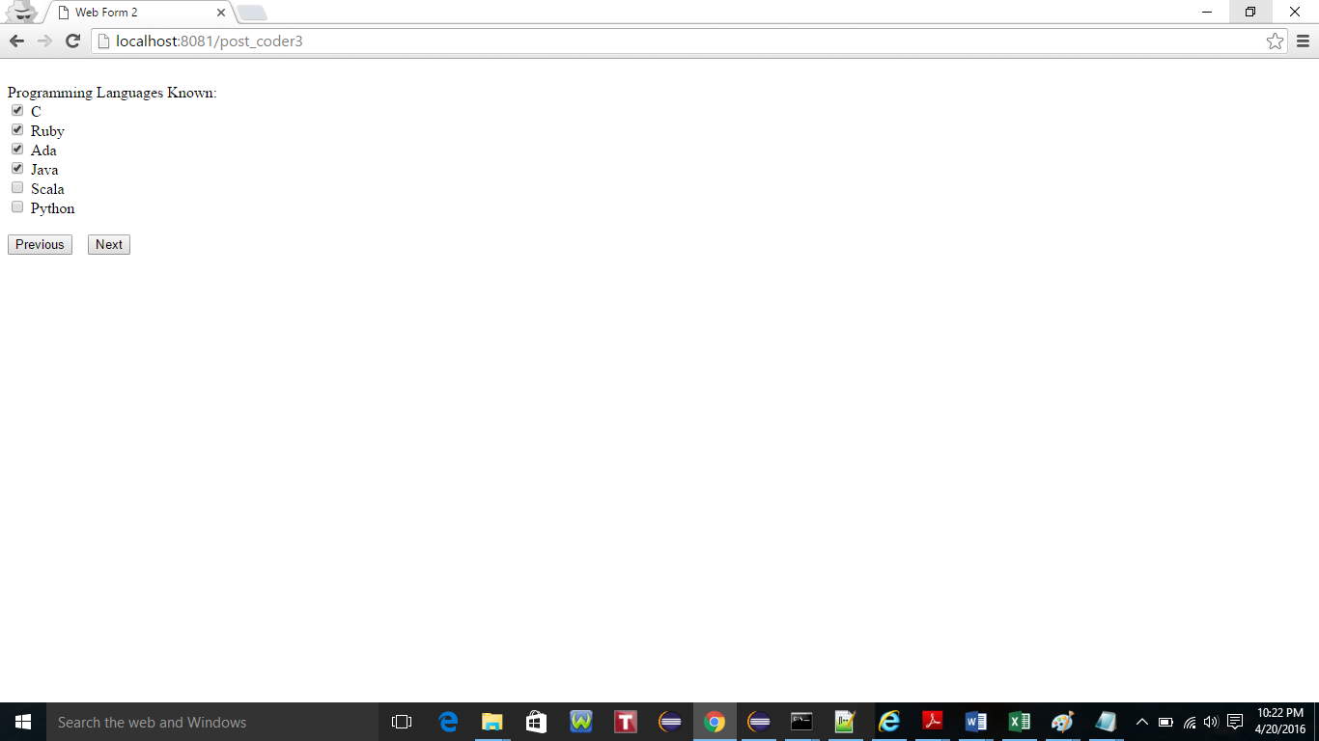

5. Select the Available on Day(s) of the week and click Next button.

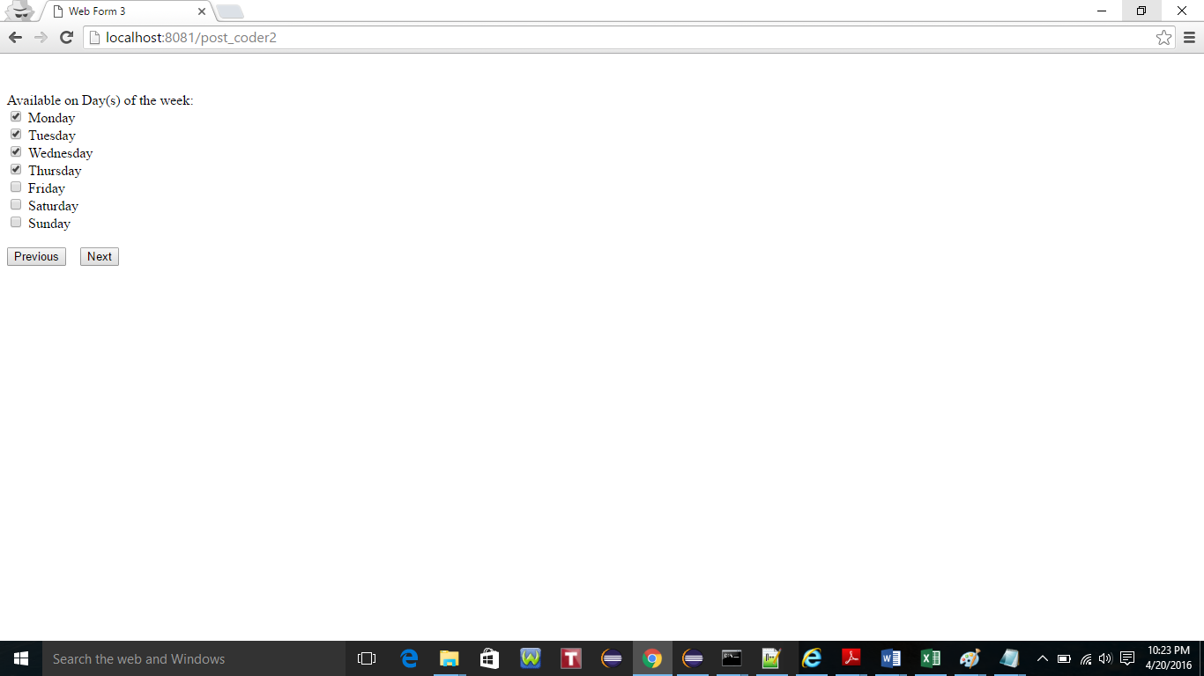

6. Enter the Contact Number and click next to Review all the information entered so far on the next screen.

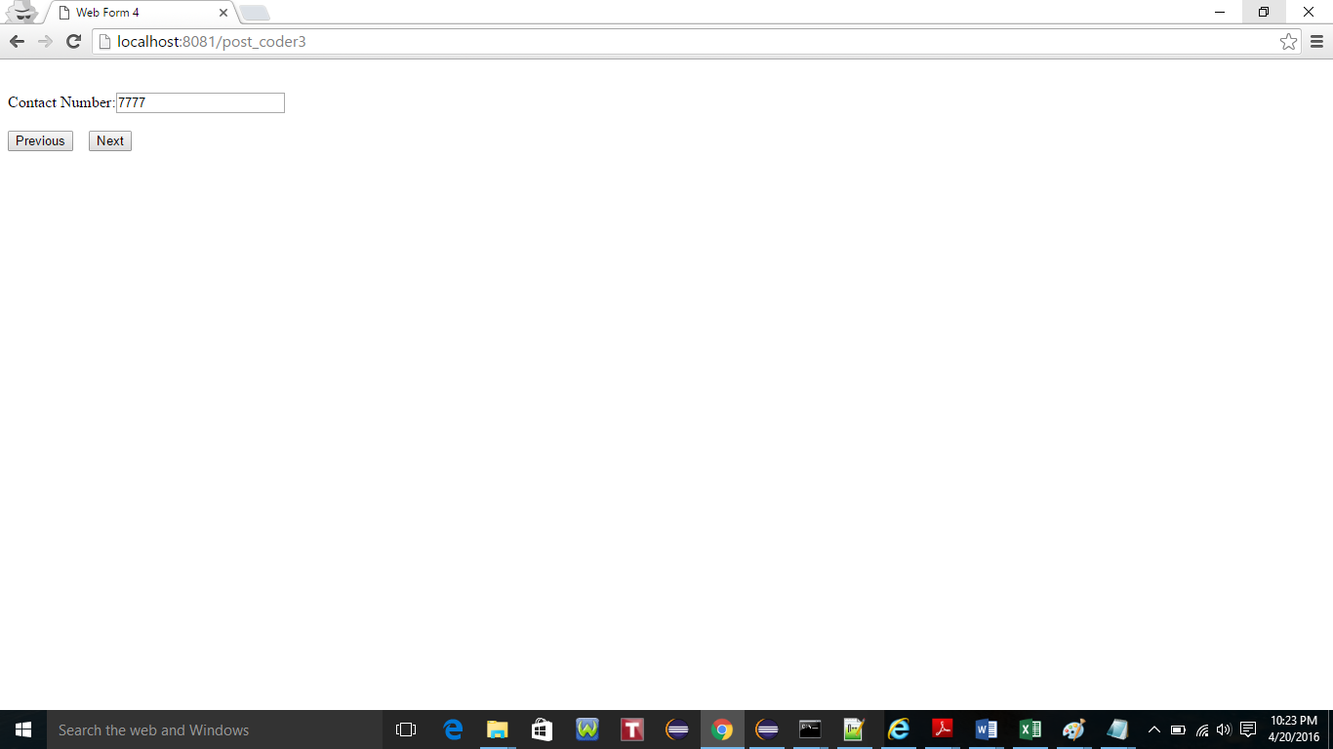

7. Verify the details entered and Click Submit to complete the registration process.

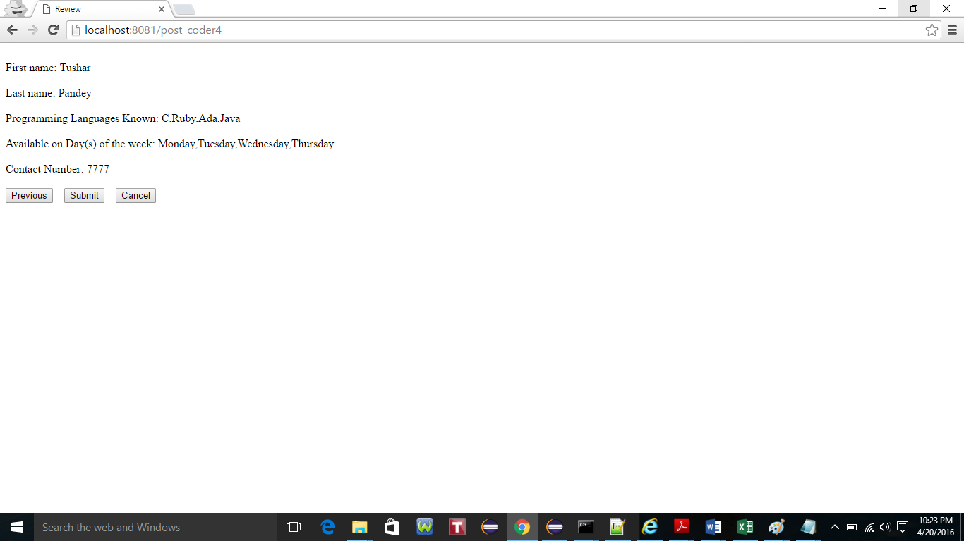

8. Upon submission of the form the control returns to the first form as shown below.



9. Goto location “C:\Users\Tushar\Documents\Lab 5” to access file ‘codersArray.txt’. Open the files and verify the details captured while inputting the details. The data is stored in the JSON format.

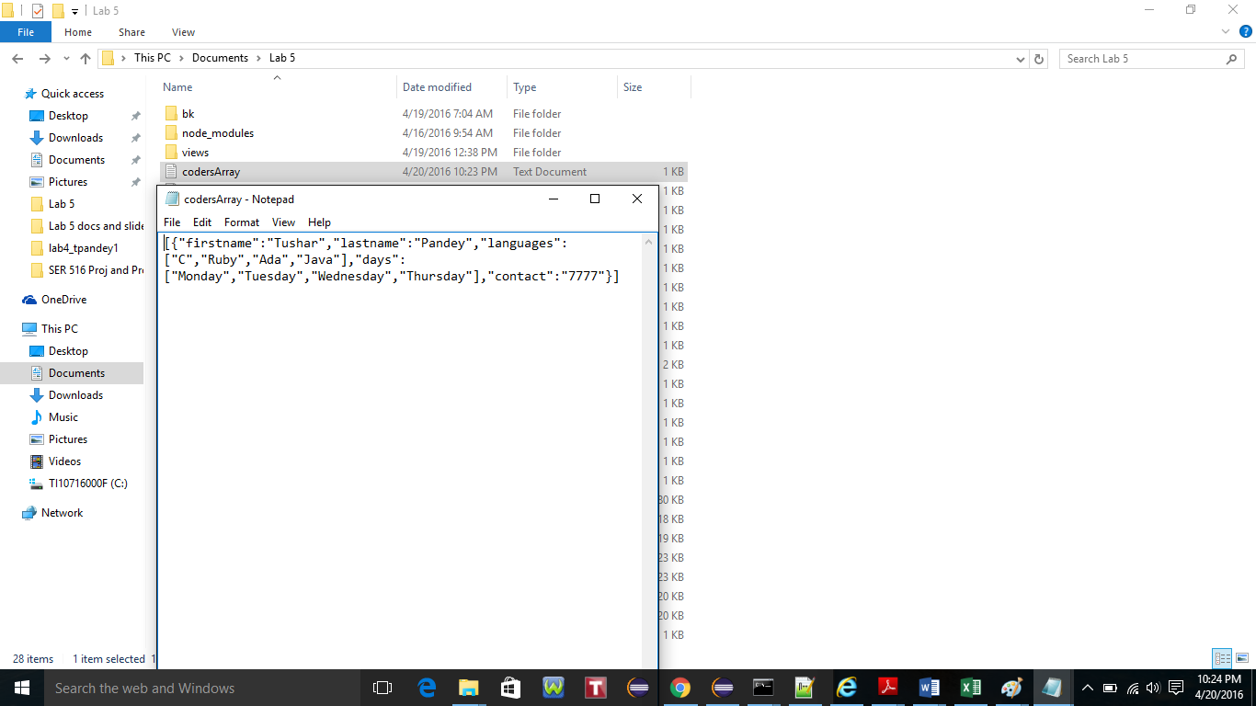

**TASK 3: EXTRA CREDIT TASK: Persist entries to MongoDB**

Source Code: task3.js

1.Task 2 is implemented using MongoDB in program task3.js

2. Start the MongoDB server by running ‘mongod’ on terminal as shown below.

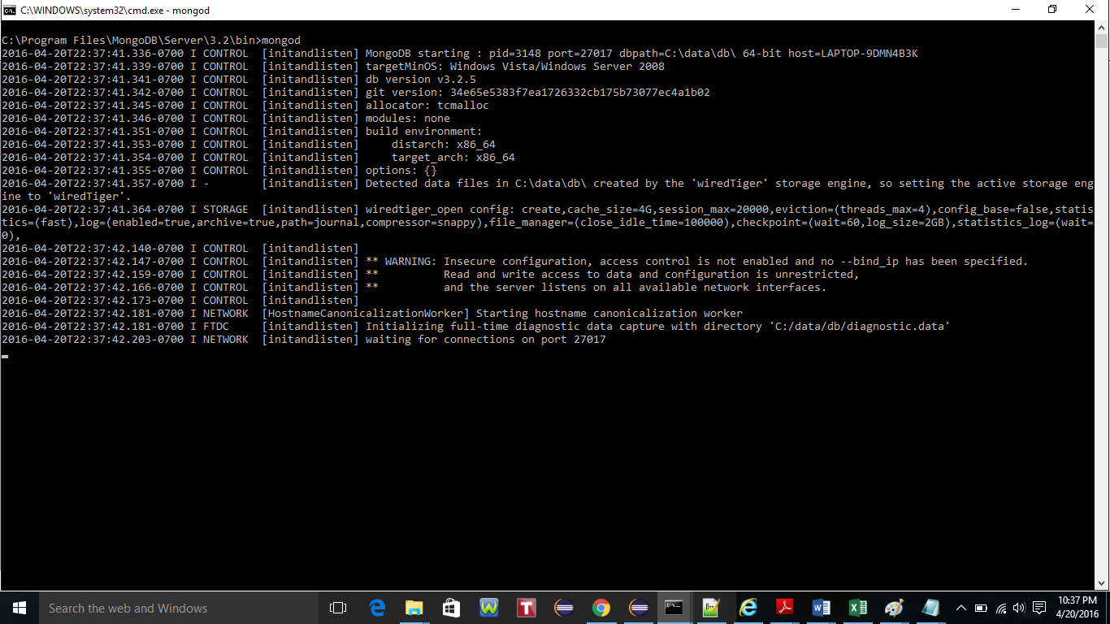

1. After starting the mongoDB server. Open another command prompt and run the program task3.js

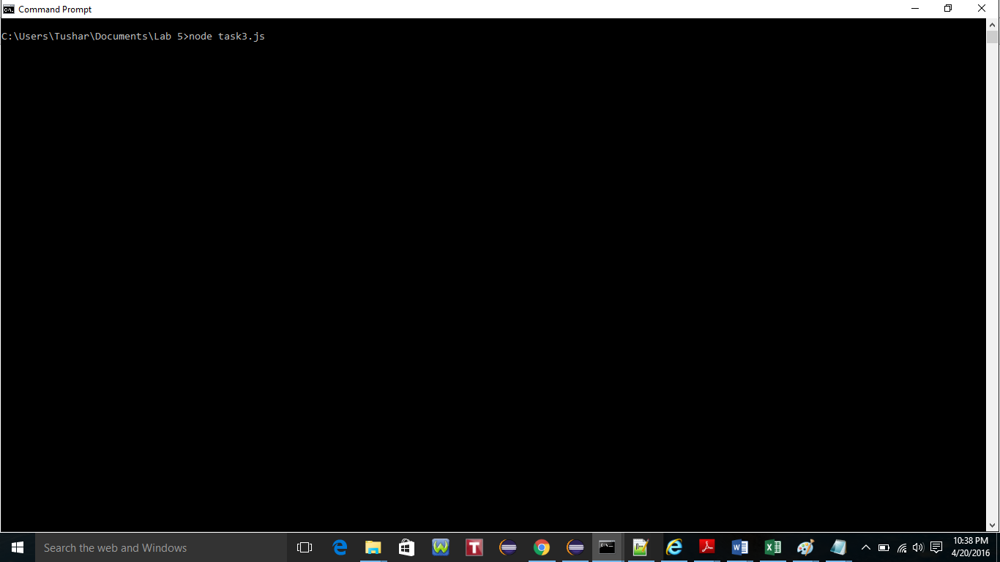

1. Goto url ‘localhost:8081’. Create a user record by providing the details like firstname and last name. Click Next button.

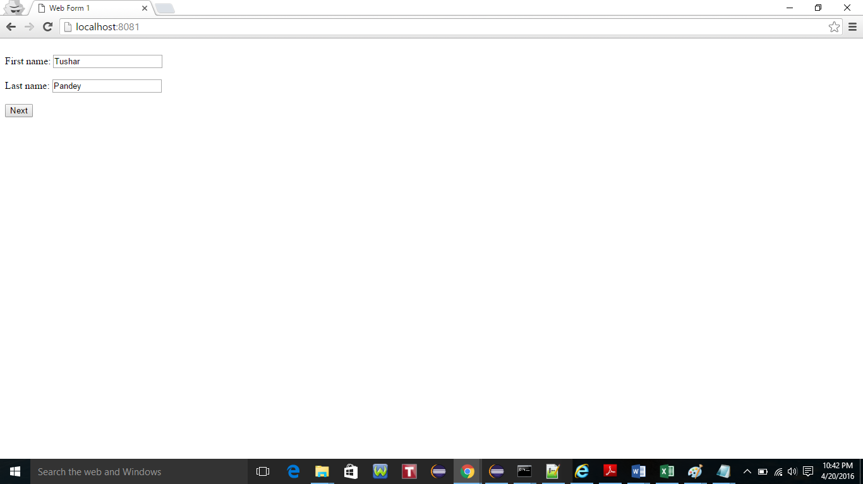

1. Select the Programming languages and Click Next.

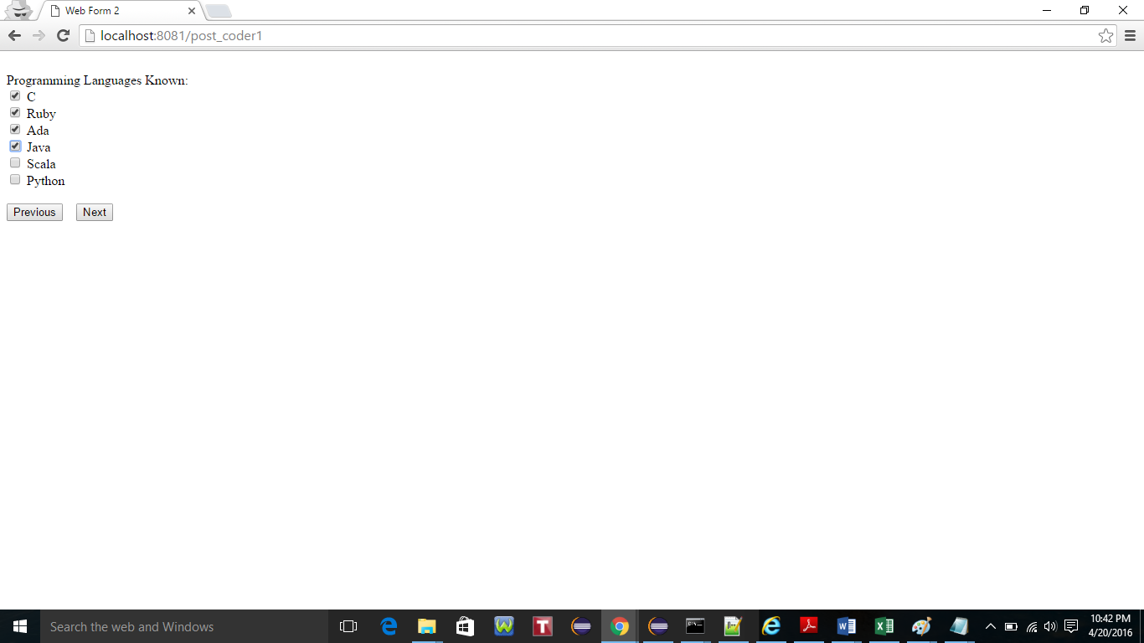

1. Similarly, select Availability on Day(s) of the week and Click Next to proceed.

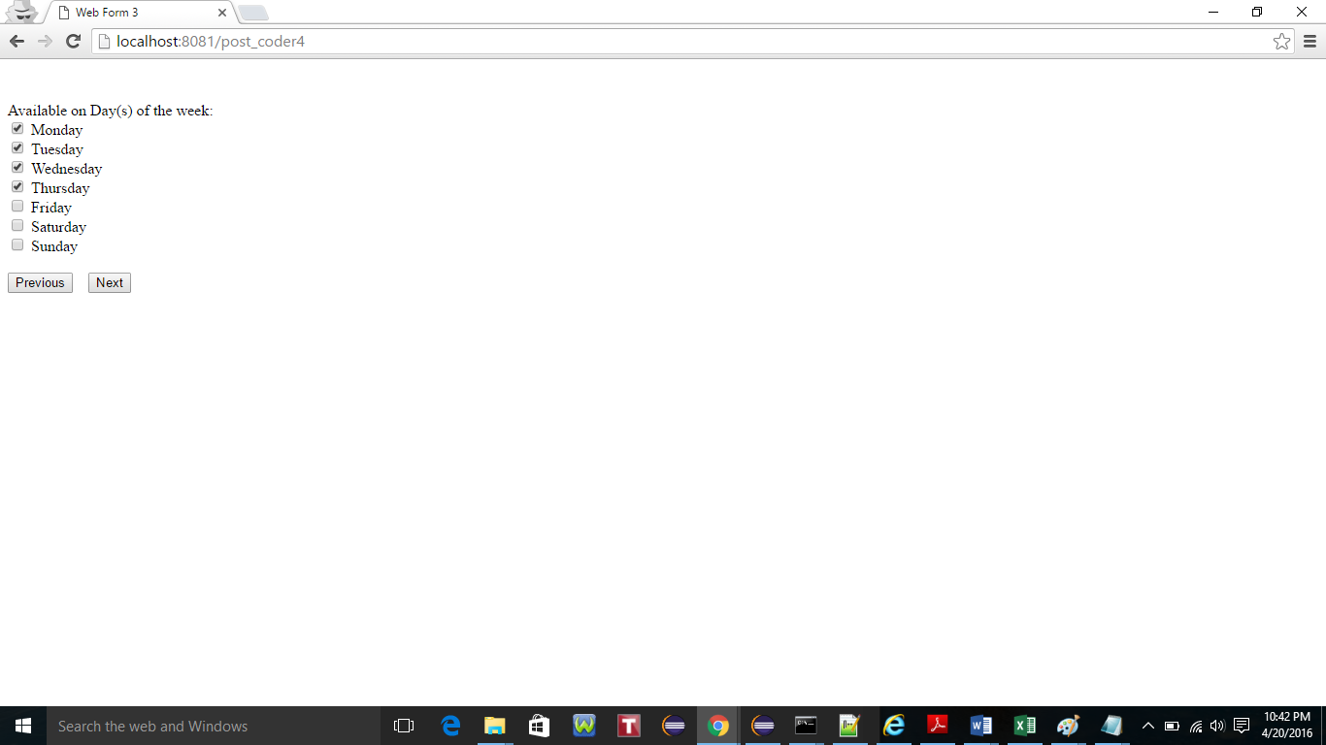

1. Enter the Contact No. and Click Next to proceed.

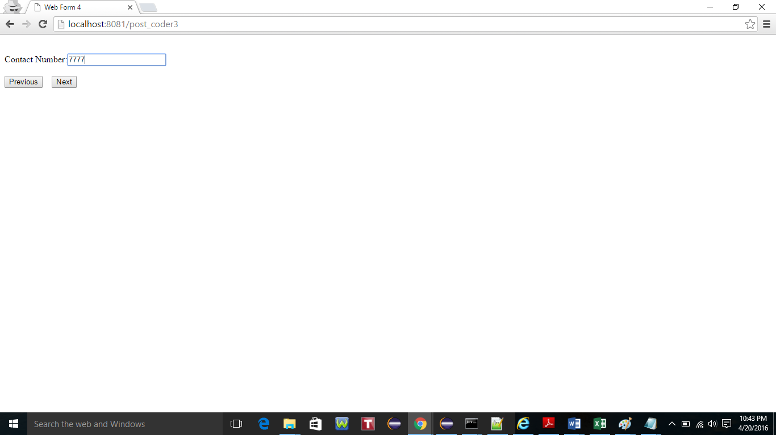

1. Review the details entered in the previous screens and Click Submit to register the user.

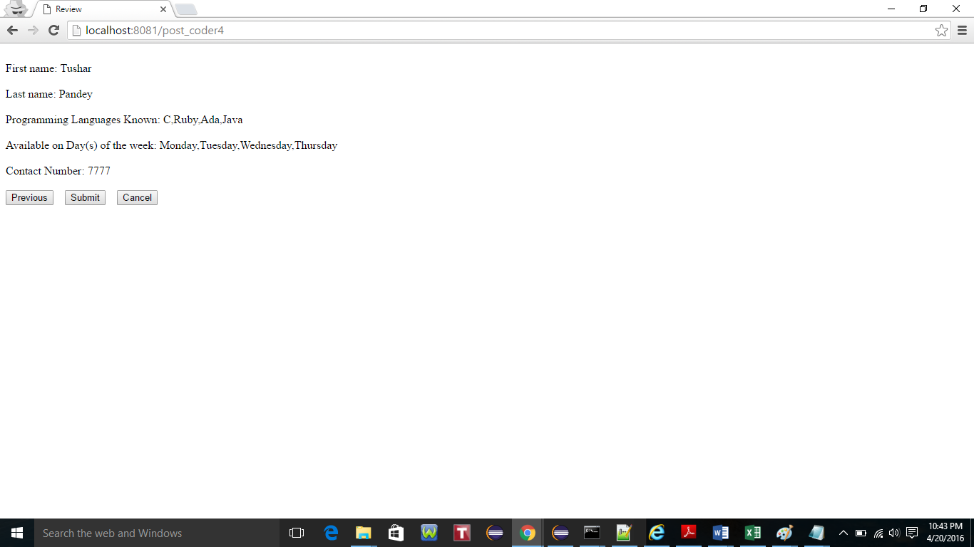

1. Upon submitting the user the returned back to the Form 1.

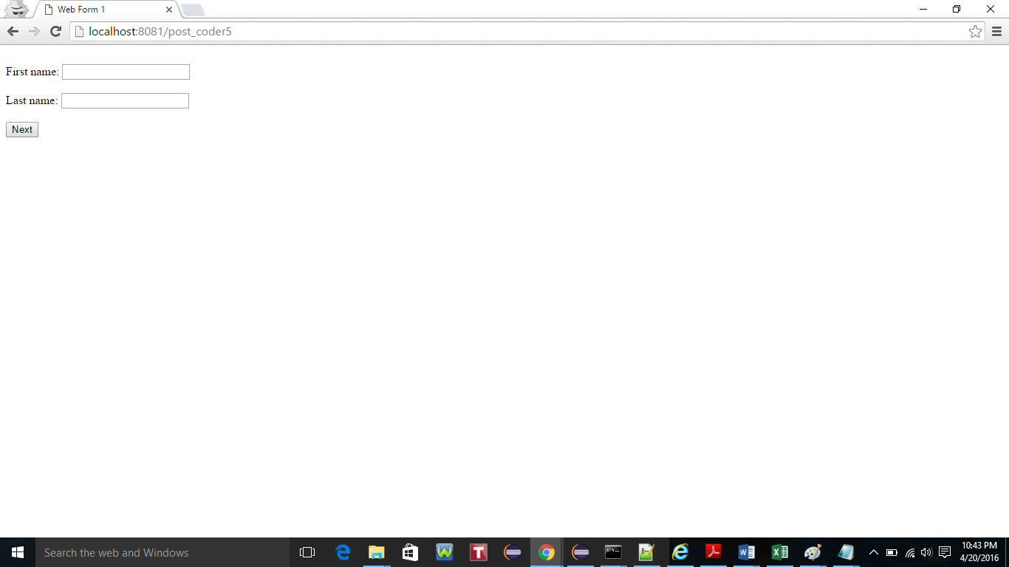

10.To verify if the values are stored properly in the collection ‘coderstable’. Open the command prompt and go to location C:\Program Files\MongoDB\Server\3.2\bin and type command ‘mongo’ as below

Type command **‘show databases’**, followed by command **‘use lab5db’** and then **‘db.coderstable.find()**’ to verify the data entered.

